

**SUBMITTED BY:**

**UQBA GULZAR (067)**

**ZUNAIRA NOOR (075)**

**ZUNAIRA KHATOON (074)**

**HADIA ZAKIR (019)**

**SUBMITTED TO:**

**Engr. AHSEN ILYAS**

**COURSE TITLE:**

**CALD LAB**

**DEPARTMENT:**

**SOFTWARE ENGINEERING**

**SECTION:**

**BSE II-B**

**LAB # 6**

**IMPLEMENTATION OF HALF ADDER AND FULL ADDER**

IMPLEMENTATION OF HALF ADDER and FULL ADDER.

* **Half Adder: Logic diagram:**

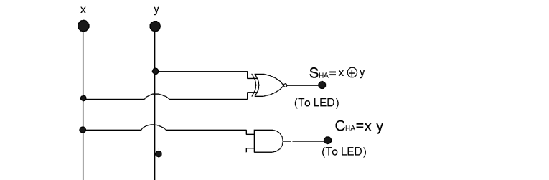

**Truth Table:**

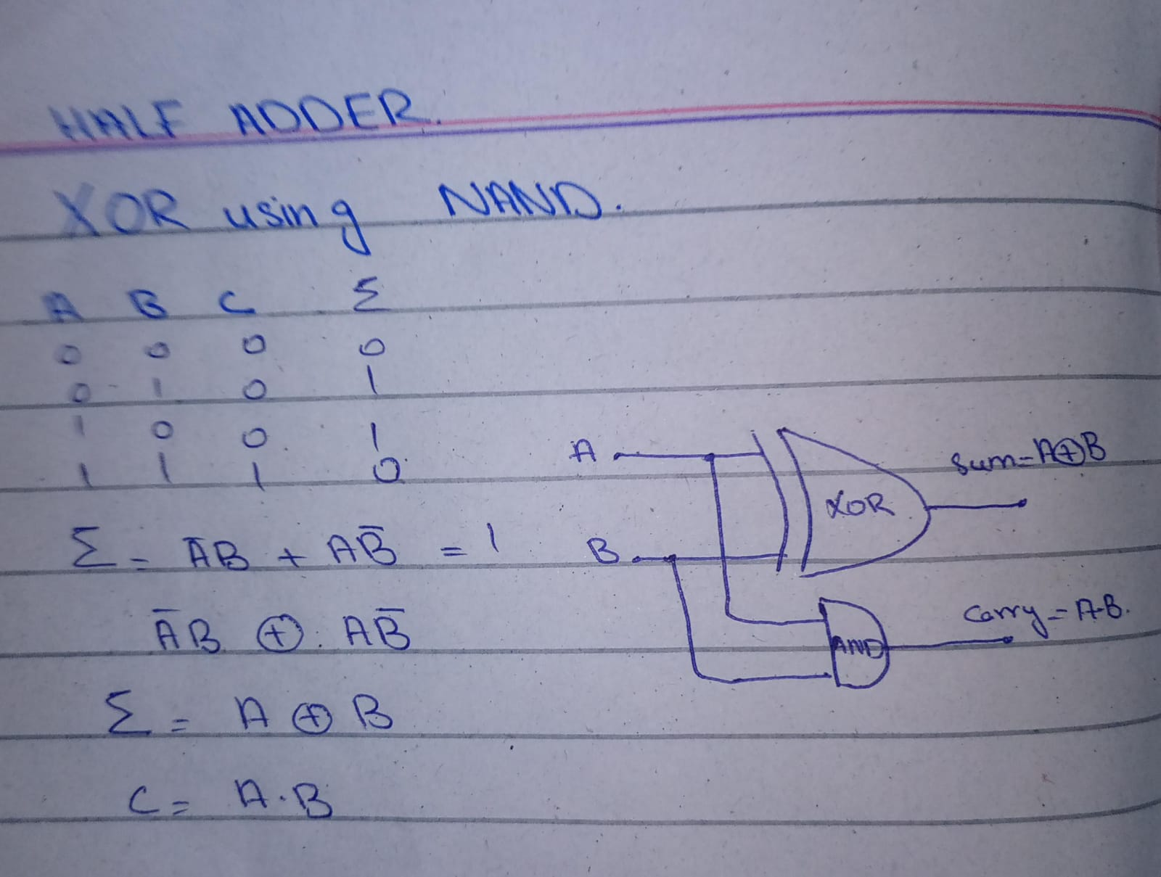

**Implementation of Half adder:**

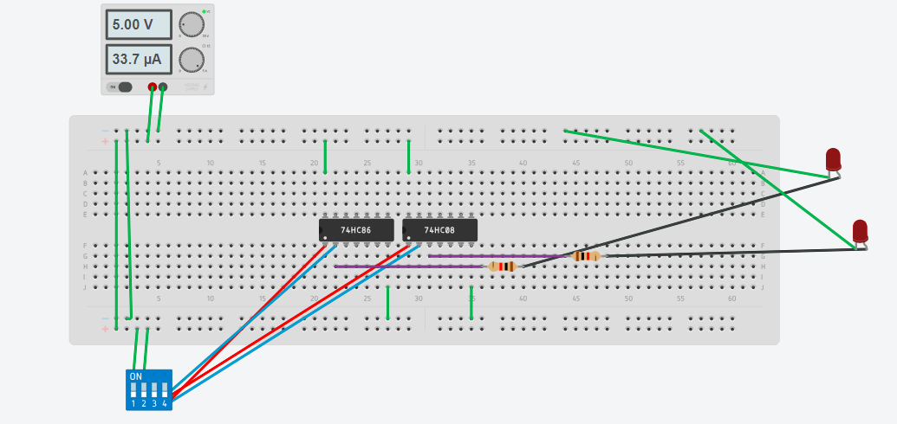

* **Full Adder:**

**Logic diagram:**

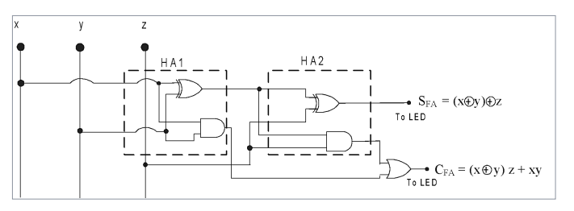

**Truth Table:**

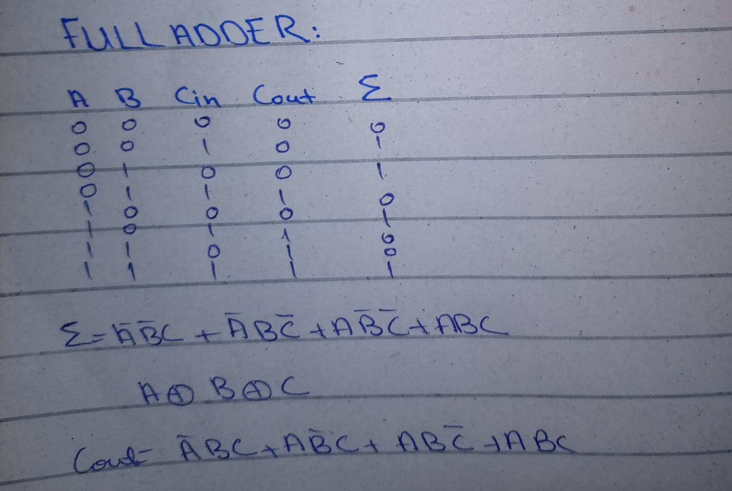

**Circuit Diagram:**

